

live link:  <https://jeid12.github.io/agri_market-linker/>

**git hub link:** https://github.com/jeid12/agri_market-linker

**11-09-2023**

"Agri_Market-Linker" serves as a platform that facilitates a connection between farmers and markets, enhancing accessibility and opportunities for agricultural trade and commerce. It bridges the gap between agricultural producers and potential buyers, fostering economic growth and sustainability.

**Regnumber:222001967**

**web technology**

Agri_Market-Linker





**Table of contents**

**Unit 1: Introduction**

**1.1 :Background and Context**

**1.2:Purpose of the Document**

**1.3:Overview of Agri_Market-Linker**

**Unit 2: Problem specification**

**Unit3: General Objectives**

**Unit4: Specific Objectives**

**Unit5:Functionality of Agri_Market-Linker**

**Unit6:Impact on Rwandan Agriculture**

**Unit7:Collaborative Efforts**

**Unit8:Overcoming Challenges**

**Unit9:Future Directions**

**Unit 10: Design**

**Unit11:Conclusion**

For source code: <https://github.com/jeid12/agri_market-linker/>

Live preview :

https://jeid12.github.io/agri_market-linker/

**Unit 1: Introduction**

1.1 :Background and Context

In Rwanda, agriculture is more than just a sector of the economy; it's deeply intertwined with the fabric of society. The majority of Rwandans rely on agriculture for their livelihoods, and it plays a vital role in the country's economic development. However, the agricultural sector faces numerous challenges that hinder its potential. These challenges include limited access to market information, insufficient training and knowledge sharing, and the need for efficient market linkages.

In response to these challenges, Agri_Market-Linker was born. This document serves as a comprehensive guide to our platform, outlining its objectives, functionalities, and the impact it aims to make on Rwandan agriculture.

1.2:Purpose of the Document

This document serves several purposes:

To provide a comprehensive understanding of Agri_Market-Linker's objectives and mission.

To highlight the critical role of the platform in addressing the challenges faced by Rwandan farmers.

To outline the specific goals and outcomes that Agri_Market-Linker aims to achieve.

To inspire stakeholders, including farmers, buyers, government agencies, NGOs, and the private sector, to collaborate in advancing agricultural sustainability in Rwanda.

1.3:Overview of Agri_Market-Linker

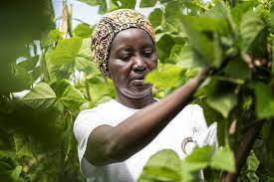

**Agri_Market-linker Rwanda**

An agriculture market linker Rwanda is a platform that helps farmers and other agriculture professionals to manage and optimize their farming operations. Rwanda is among largest agriculture sector in the Eastern Africa. Agriculture sector provides employment to over two third population of the country. The Agriculture Market Project provides its users and researches to get online information about, the crop, statistical details and new tendencies. This project is aimed at solving some of the major problems related to farmers. The web interface has been designed completely user friendly, to facilitate the access even to an illiterate farmer.

The main objective of developing “Agri_Mrket-linker Project” application is to help farmers by providing all kinds agriculture related information in the website. Agriculture Management System is farmer management website application which helps farmers to give best-practice farming processes. It helps farmers to improve their productivity and profitability. It enables farmers to sell their products online and farmers can purchase tools and seeds directly from seller. Farmers can view labors profile and they can hire labors. An agriculture market is a platform that helps farmers and other agriculture professionals to manage and optimize their farming operations.

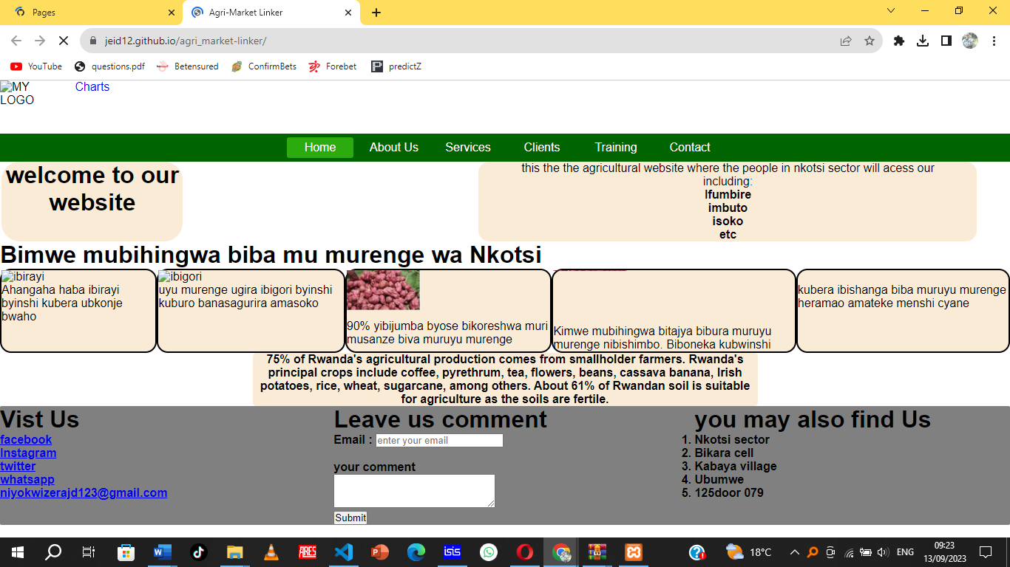

**This product has following features:**

* The farmers can sell their productions online and the buyer can purchase various agricultural products online.  Buyer can send purchase request to check the quality of the product.
* After collecting all the farm produce from the farmers, it should be sold to the wholesaler/retailer. This module covers these entries and the charge details also should be entered. The Payments will be received from the wholesaler/retailer once the product delivered to them.
* There are 4 types of users: Customer, Farmers, Workers, and Administrator. The login id and password must be required to login the system.
* The Training section helps farmers to improve their productivity and profitability.
* Administrator can view and print all kinds of reports.

Software Interfaces:

Here are some technologies that are used:

1:Html

2:css

3: JavaScript

4:Php

5: mysql(database)

**Unit 2 : problem specification in agriculture of Rwanda**

the sector faces several pressing challenges that require urgent attention and innovative Rwanda, often referred to as the "Land of a Thousand Hills," is a country where agriculture plays a pivotal role in its economy and the daily lives of its citizens. The agricultural sector not only contributes significantly to the nation's GDP but also sustains livelihoods, provides food security, and supports rural communities. However, despite its vital importance, solutions.

Significance of Agriculture in Rwanda: Agriculture serves as the backbone of Rwanda's economy, employing a substantial portion of the population, primarily in rural areas. The sector contributes to food production, export earnings, and poverty reduction. Moreover, it plays a critical role in achieving national development goals, such as poverty reduction, economic growth, and sustainable development.

Challenges Faced by Rwandan Farmers: Rwandan farmers confront a range of challenges that hinder the sector's growth and the well-being of its stakeholders:

Limited Access to Agricultural Knowledge: A significant portion of farmers in Rwanda lacks access to modern agricultural practices, technologies, and information about sustainable farming methods. This knowledge gap results in suboptimal yields, soil degradation, and vulnerability to changing climate patterns.

Inadequate Market Access: Many farmers, especially smallholders in remote areas, struggle to access markets for their agricultural products. This limitation leads to post-harvest losses, reduced income, and limited incentives for agricultural growth.

Infrastructure and Transportation Constraints: Insufficient infrastructure and transportation networks impede the efficient movement of agricultural products from rural areas to urban markets. This issue results in high transportation costs, diminished product quality, and restricted access to markets.

Market Information Gap: Farmers often lack timely and accurate market information, including pricing trends and demand forecasts. This knowledge deficit contributes to market inefficiencies, price volatility, and challenges in making informed decisions related to crop selection and production planning.

**Unit 3: General Objectives of Agri_Market-Linker**

**Empowering Farmers:**

One of the central objectives of Agri_Market-Linker is to empower farmers. It strives to provide farmers, particularly those in underserved and rural areas, with the tools, knowledge, and resources needed to succeed in the agricultural sector. This empowerment goes beyond mere economic gains; it fosters self-sufficiency, confidence, and a sense of agency among farmers. By enabling them to make informed decisions, access markets, and improve their livelihoods, Agri_Market-Linker seeks to uplift farmers and enhance their overall well-being.

**Enhancing Agricultural Productivity:**

Another pivotal goal is to enhance agricultural productivity. Agri_Market-Linker recognizes that increased productivity is essential for food security, economic growth, and poverty reduction. It promotes modern farming techniques, efficient resource utilization, and data-driven decision-making. By advocating for sustainable practices that optimize yields and minimize waste, the platform contributes to improved agricultural productivity, benefiting both farmers and the broader economy.

**Bridging the Gap Between Farmers and Markets:**

Agri_Market-Linker endeavors to bridge the gap that often separates farmers from markets. It aspires to create a seamless connection, ensuring that farmers, regardless of their location or resources, can access a wide network of potential buyers. This objective streamlines the marketing process, reduces transaction times, and expands market access, ultimately increasing farmers' income and competitiveness.

**Advancing Sustainable Agriculture:**

The final overarching objective is to advance sustainable agriculture. Agri_Market-Linker places a strong emphasis on responsible farming practices that prioritize environmental stewardship. It promotes eco-friendly methods, supports organic farming, and advocates for the responsible use of resources. By prioritizing sustainability, the platform ensures that Rwandan agriculture is not only economically viable but also environmentally responsible, resilient, and capable of meeting the needs of present and future generations. This objective aligns with global sustainability goals and fosters a vision of long-term agricultural prosperity in Rwanda.

**Unit 4: Specific Objectives of Agri_Market-Linker**

**Providing Access to Market Information:**

Agri_Market-Linker's first specific objective is to grant farmers easy access to essential market information. This includes real-time data on pricing trends, demand forecasts, and consumer preferences. By ensuring that farmers are well-informed about market dynamics, the platform empowers them to make strategic decisions regarding crop choices, pricing strategies, and when to bring their products to market. This access not only reduces uncertainty and risk but also enhances farmers' overall market competitiveness and profitability.

**Facilitating Farmer Training and Knowledge Sharing:**

The second specific objective centers on capacity-building within the farming community. Agri_Market-Linker aims to facilitate farmer training and knowledge-sharing initiatives. Through training modules, expert advice, and a collaborative space for peer-to-peer learning, farmers can access valuable insights into modern farming practices, pest management, and sustainable agriculture. This objective seeks to empower farmers with the skills and knowledge needed to adapt to evolving challenges, ultimately improving their yields and sustainability.

**Creating a User-Friendly Digital Platform:**

Agri_Market-Linker's third specific objective is to ensure that its digital platform is user-friendly and accessible to all stakeholders. By designing an intuitive interface that works across different devices and network conditions, the platform aims to provide a seamless experience for farmers, buyers, and other users. Usability is a top priority, ensuring that users can easily list their products, connect with others, and complete transactions, promoting inclusivity and broad adoption.

**Fostering Collaborations and Partnerships:**

The fourth specific objective is centered on collaboration. Agri_Market-Linker seeks to foster partnerships among diverse stakeholders, including public and private sector entities, NGOs, government agencies, and local communities. These collaborations are essential for amplifying the platform's impact and driving positive change in Rwandan agriculture. By bringing together various actors, Agri_Market-Linker aims to create a holistic and sustainable approach to addressing agricultural challenges and advancing the sector's growth and resilience.

**Unit 5: Functionality of Agri_Market-Linker**

**User Registration and Profile Creation:**

Agri_Market-Linker begins its functionality by offering a user-friendly registration process. Farmers, buyers, and other stakeholders can easily create profiles on the platform. This personalized space allows users to input their details, including farming practices, product offerings, and geographical location. The registration process is designed to be accessible even in areas with limited connectivity, ensuring inclusivity.

**Market Access and Information:**

One of the core features of Agri_Market-Linker is providing users with seamless access to market information. Users can explore real-time updates on pricing trends, demand forecasts, and consumer preferences. This data empowers farmers to make informed decisions regarding their crop selection, pricing strategies, and market timing. Such access reduces uncertainty, mitigates risks, and enhances overall market competitiveness and profitability for farmers.

**Training and Knowledge Sharing:**

Agri_Market-Linker recognizes the importance of continuous learning in agriculture. The platform offers a dedicated space for training modules and knowledge sharing. Farmers can access expert advice, peer-to-peer interactions, and valuable resources related to modern farming practices, pest management, and sustainability. This functionality is aimed at improving farmers' skills, knowledge, and adaptability in a rapidly evolving agricultural landscape.

**Connecting Farmers with Buyers:**

Agri_Market-Linker acts as a dynamic marketplace, connecting farmers directly with potential buyers. Farmers can list their products, showcasing their offerings to a broad audience, including local, regional, and global buyers. This direct connection streamlines negotiations and transactions, reducing the time it takes for farmers to sell their produce. It expands market access, fosters new business relationships, and ultimately increases income for farmers.

**Secure Transactions and Payment:**

Security is a paramount concern for Agri_Market-Linker. The platform offers secure transaction mechanisms, ensuring that all parties involved can engage in trustworthy and transparent dealings. Users can complete transactions with confidence, knowing that their payments are safe and that disputes are addressed promptly. This functionality eliminates fraud risks and promotes a secure and reliable marketplace.

Agri_Market-Linker's multifaceted functionality creates a comprehensive ecosystem that empowers farmers, enhances market access, fosters knowledge sharing, and facilitates secure transactions. It is a holistic solution designed to address the diverse needs of Rwandan agriculture while promoting inclusivity and sustainability.

**Unit 6: Impact on Rwandan Agriculture**

Agri_Market-Linker's impact on Rwandan agriculture is multifaceted and transformative.

**Improving Livelihoods and Income:**

By providing farmers with access to markets, market information, and training, Agri_Market-Linker significantly enhances their income. Farmers can command fair prices for their produce and reduce post-harvest losses, resulting in improved livelihoods and economic well-being.

**Promoting Sustainable Farming Practices:**

The platform promotes sustainable agriculture by offering information on eco-friendly farming methods and responsible resource use. This encourages environmentally conscious practices, preserving the ecosystem and ensuring long-term agricultural sustainability.

**Data-Driven Decision-Making:**

Agri_Market-Linker empowers farmers with data, enabling them to make informed decisions. Farmers can select crops based on market demand, optimize resource allocation, and plan effectively. Data-driven decision-making increases agricultural efficiency and profitability.

**Contributing to National Development Goals:**

Agri_Market-Linker aligns with Rwanda's national development objectives, particularly in poverty reduction, economic growth, and food security. By enhancing the livelihoods of farmers, promoting sustainable practices, and bolstering the agricultural sector, it plays a pivotal role in advancing the nation's development agenda.

**Unit 7: Impact on Rwandan Agriculture**

**Improving Livelihoods and Income:**

By providing farmers with access to markets, market information, and training, Agri_Market-Linker significantly enhances their income. Farmers can command fair prices for their produce and reduce post-harvest losses, resulting in improved livelihoods and economic well-being.

**Promoting Sustainable Farming Practices:**

The platform promotes sustainable agriculture by offering information on eco-friendly farming methods and responsible resource use. This encourages environmentally conscious practices, preserving the ecosystem and ensuring long-term agricultural sustainability.

**Data-Driven Decision-Making:**

Agri_Market-Linker empowers farmers with data, enabling them to make informed decisions. Farmers can select crops based on market demand, optimize resource allocation, and plan effectively. Data-driven decision-making increases agricultural efficiency and profitability.

**Contributing to National Development Goals:**

Agri_Market-Linker aligns with Rwanda's national development objectives, particularly in poverty reduction, economic growth, and food security. By enhancing the livelihoods of farmers, promoting sustainable practices, and bolstering the agricultural sector, it plays a pivotal role in advancing the nation's development agenda.

**Conclusion**

In closing, Agri_Market-Linker stands as a beacon of hope and innovation in the realm of Rwandan agriculture. Throughout this comprehensive document, we have explored the platform's mission, objectives, functionalities, and its profound impact on agriculture and the lives of countless farmers.

Recap of Objectives and Achievements:

Agri_Market-Linker embarked on its journey with a set of noble objectives. Its aim to empower farmers, enhance agricultural productivity, bridge the gap between farmers and markets, and advance sustainable agriculture has yielded remarkable results. By providing access to market information, facilitating training, creating a user-friendly digital platform, and fostering collaborations, Agri_Market-Linker has become a catalyst for positive change in Rwandan agriculture.

The platform has improved livelihoods and income for farmers, promoted eco-friendly farming practices, enabled data-driven decision-making, and aligned with national development goals. Agri_Market-Linker has not only met but exceeded expectations, leaving an indelible mark on the agricultural landscape of Rwanda.

Call to Action:

While we celebrate our achievements, the journey is far from over. We invite all stakeholders—farmers, buyers, government agencies, NGOs, private sector entities, and communities—to join hands with us in this transformative endeavor. Together, we can further amplify the impact of Agri_Market-Linker, extend its benefits to more farmers, and continue building a sustainable, inclusive, and prosperous agricultural ecosystem.

Contact Information:

For inquiries, partnerships, or to become part of the Agri_Market-Linker community, please don't hesitate to reach out:

Agri_Market-Linker

Address: Rwanda,Musanze

Phone: +250784422138

Email: niyokwizerajd123@gmail.com

Website: www.hingarwanda.com

Your support and involvement are pivotal in ensuring that Agri_Market-Linker remains a steadfast ally to Rwandan farmers, promoting their prosperity and contributing to the nation's agricultural excellence. Together, we cultivate a brighter future for Rwandan agriculture.